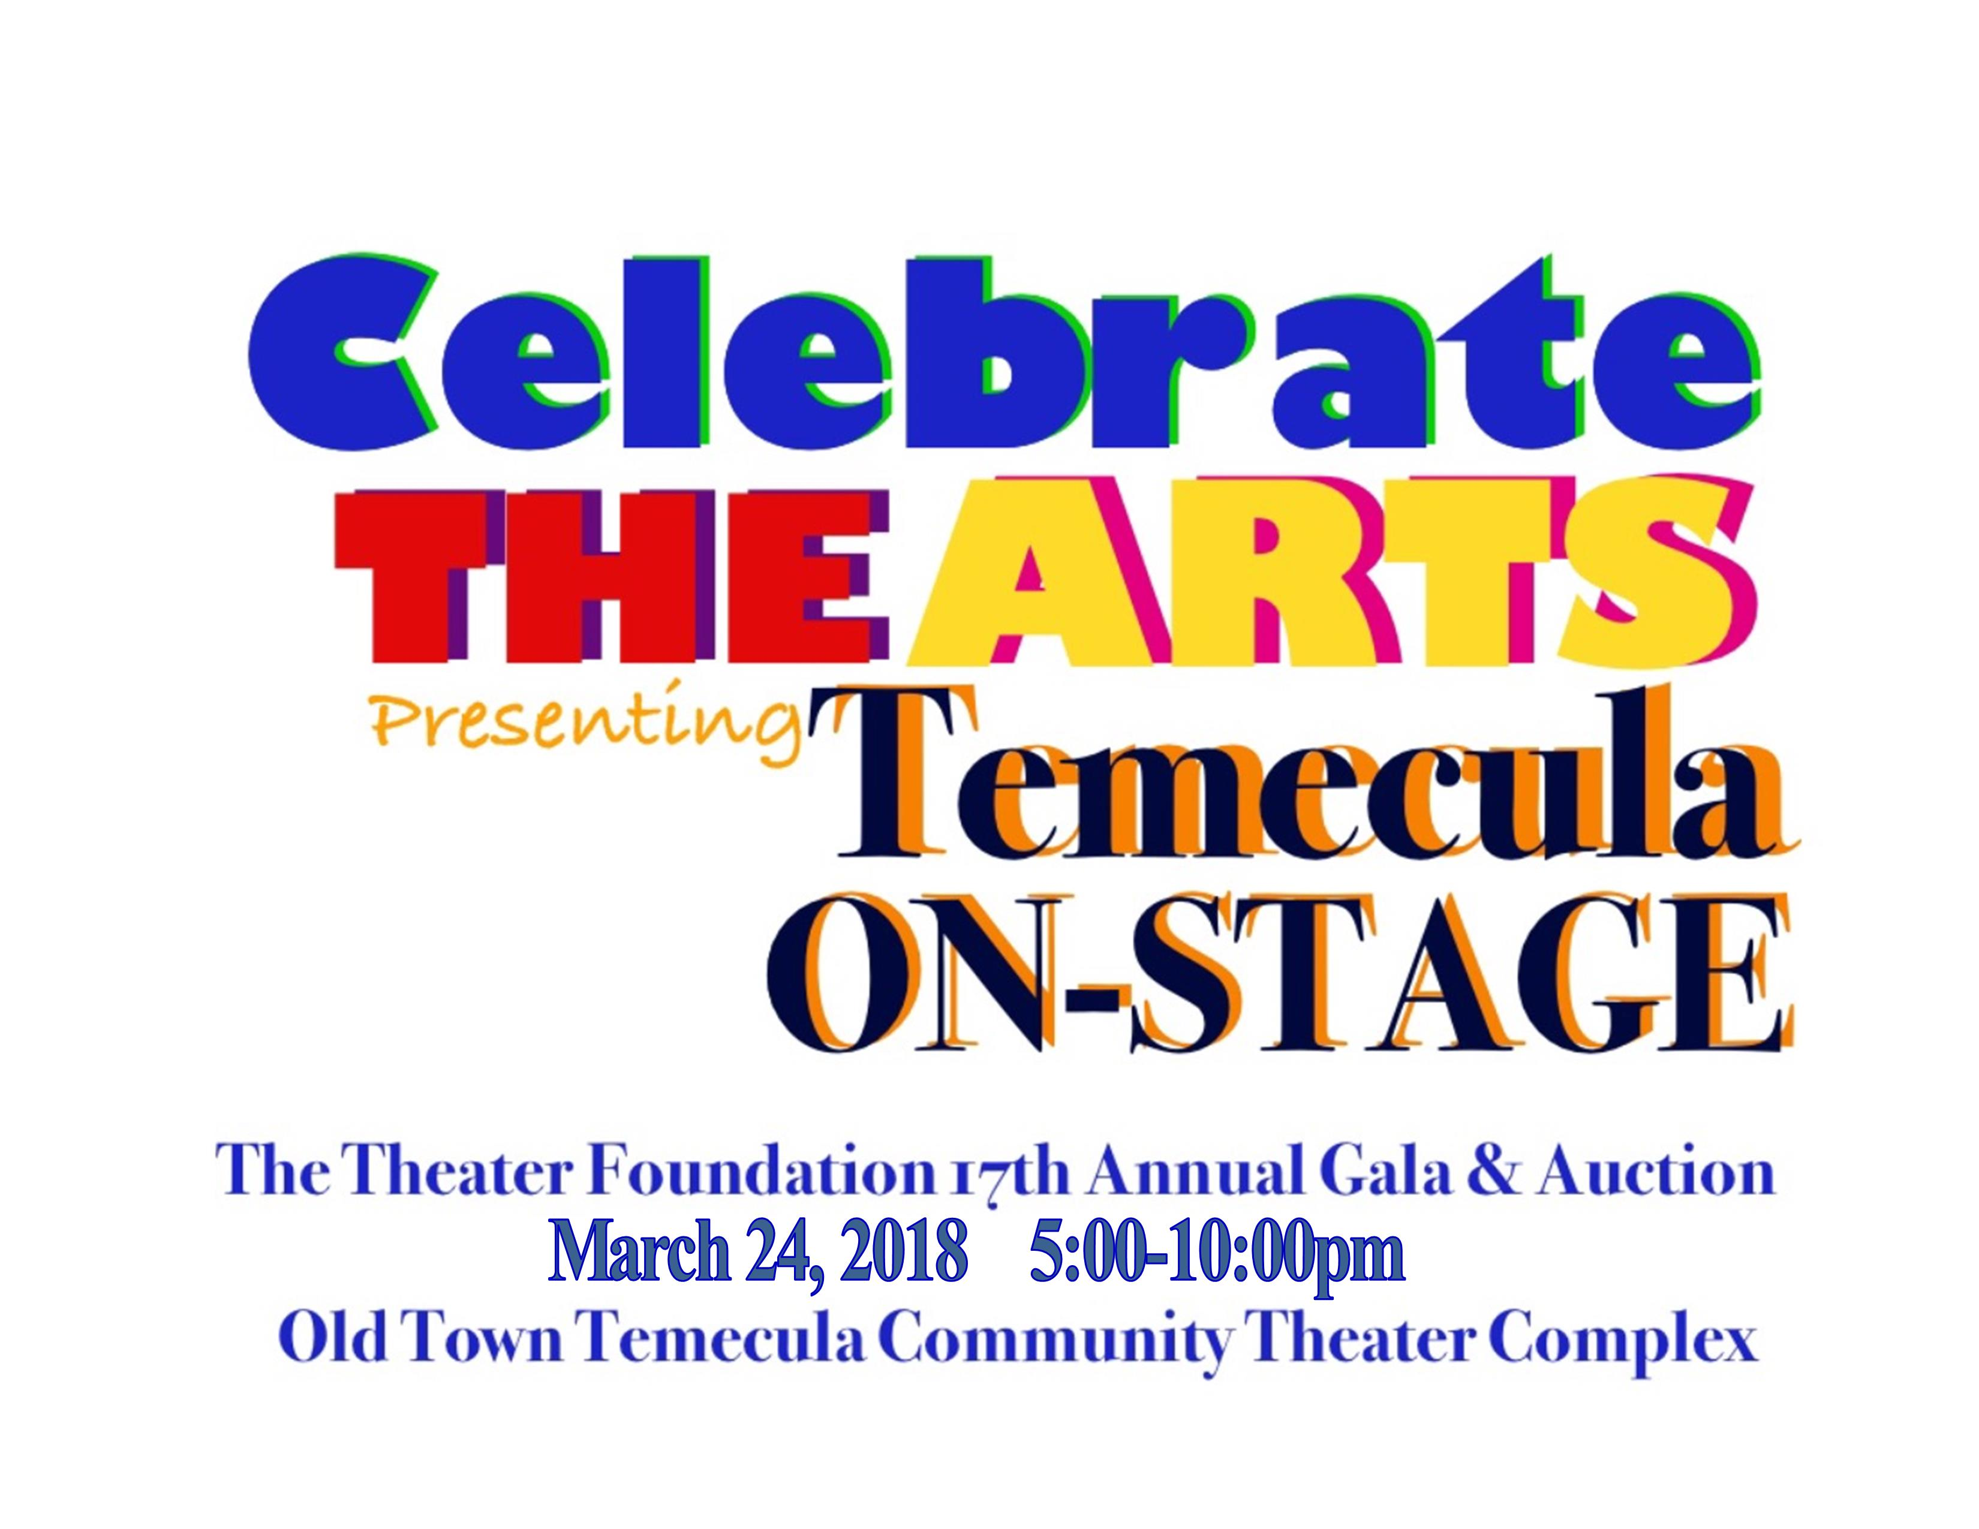
17th Annual Gala & Auction
to benefit
The Theater Foundation

..

Donor Information
Business Name: ____________________________________________________________________________
Address: _____________________________________________________________________________
Contact Person: ____________________________________________________________________________
Phone: __________________________________ Email: ____________________________

Item Information
Item: ___________________________________________________________ Value: _____
Description: _____________________________________________________________________________
_____________________________________________________________________________
_____________________________________________________________________________
Please Return Your Donation Form
Thank You for Supporting the Arts!

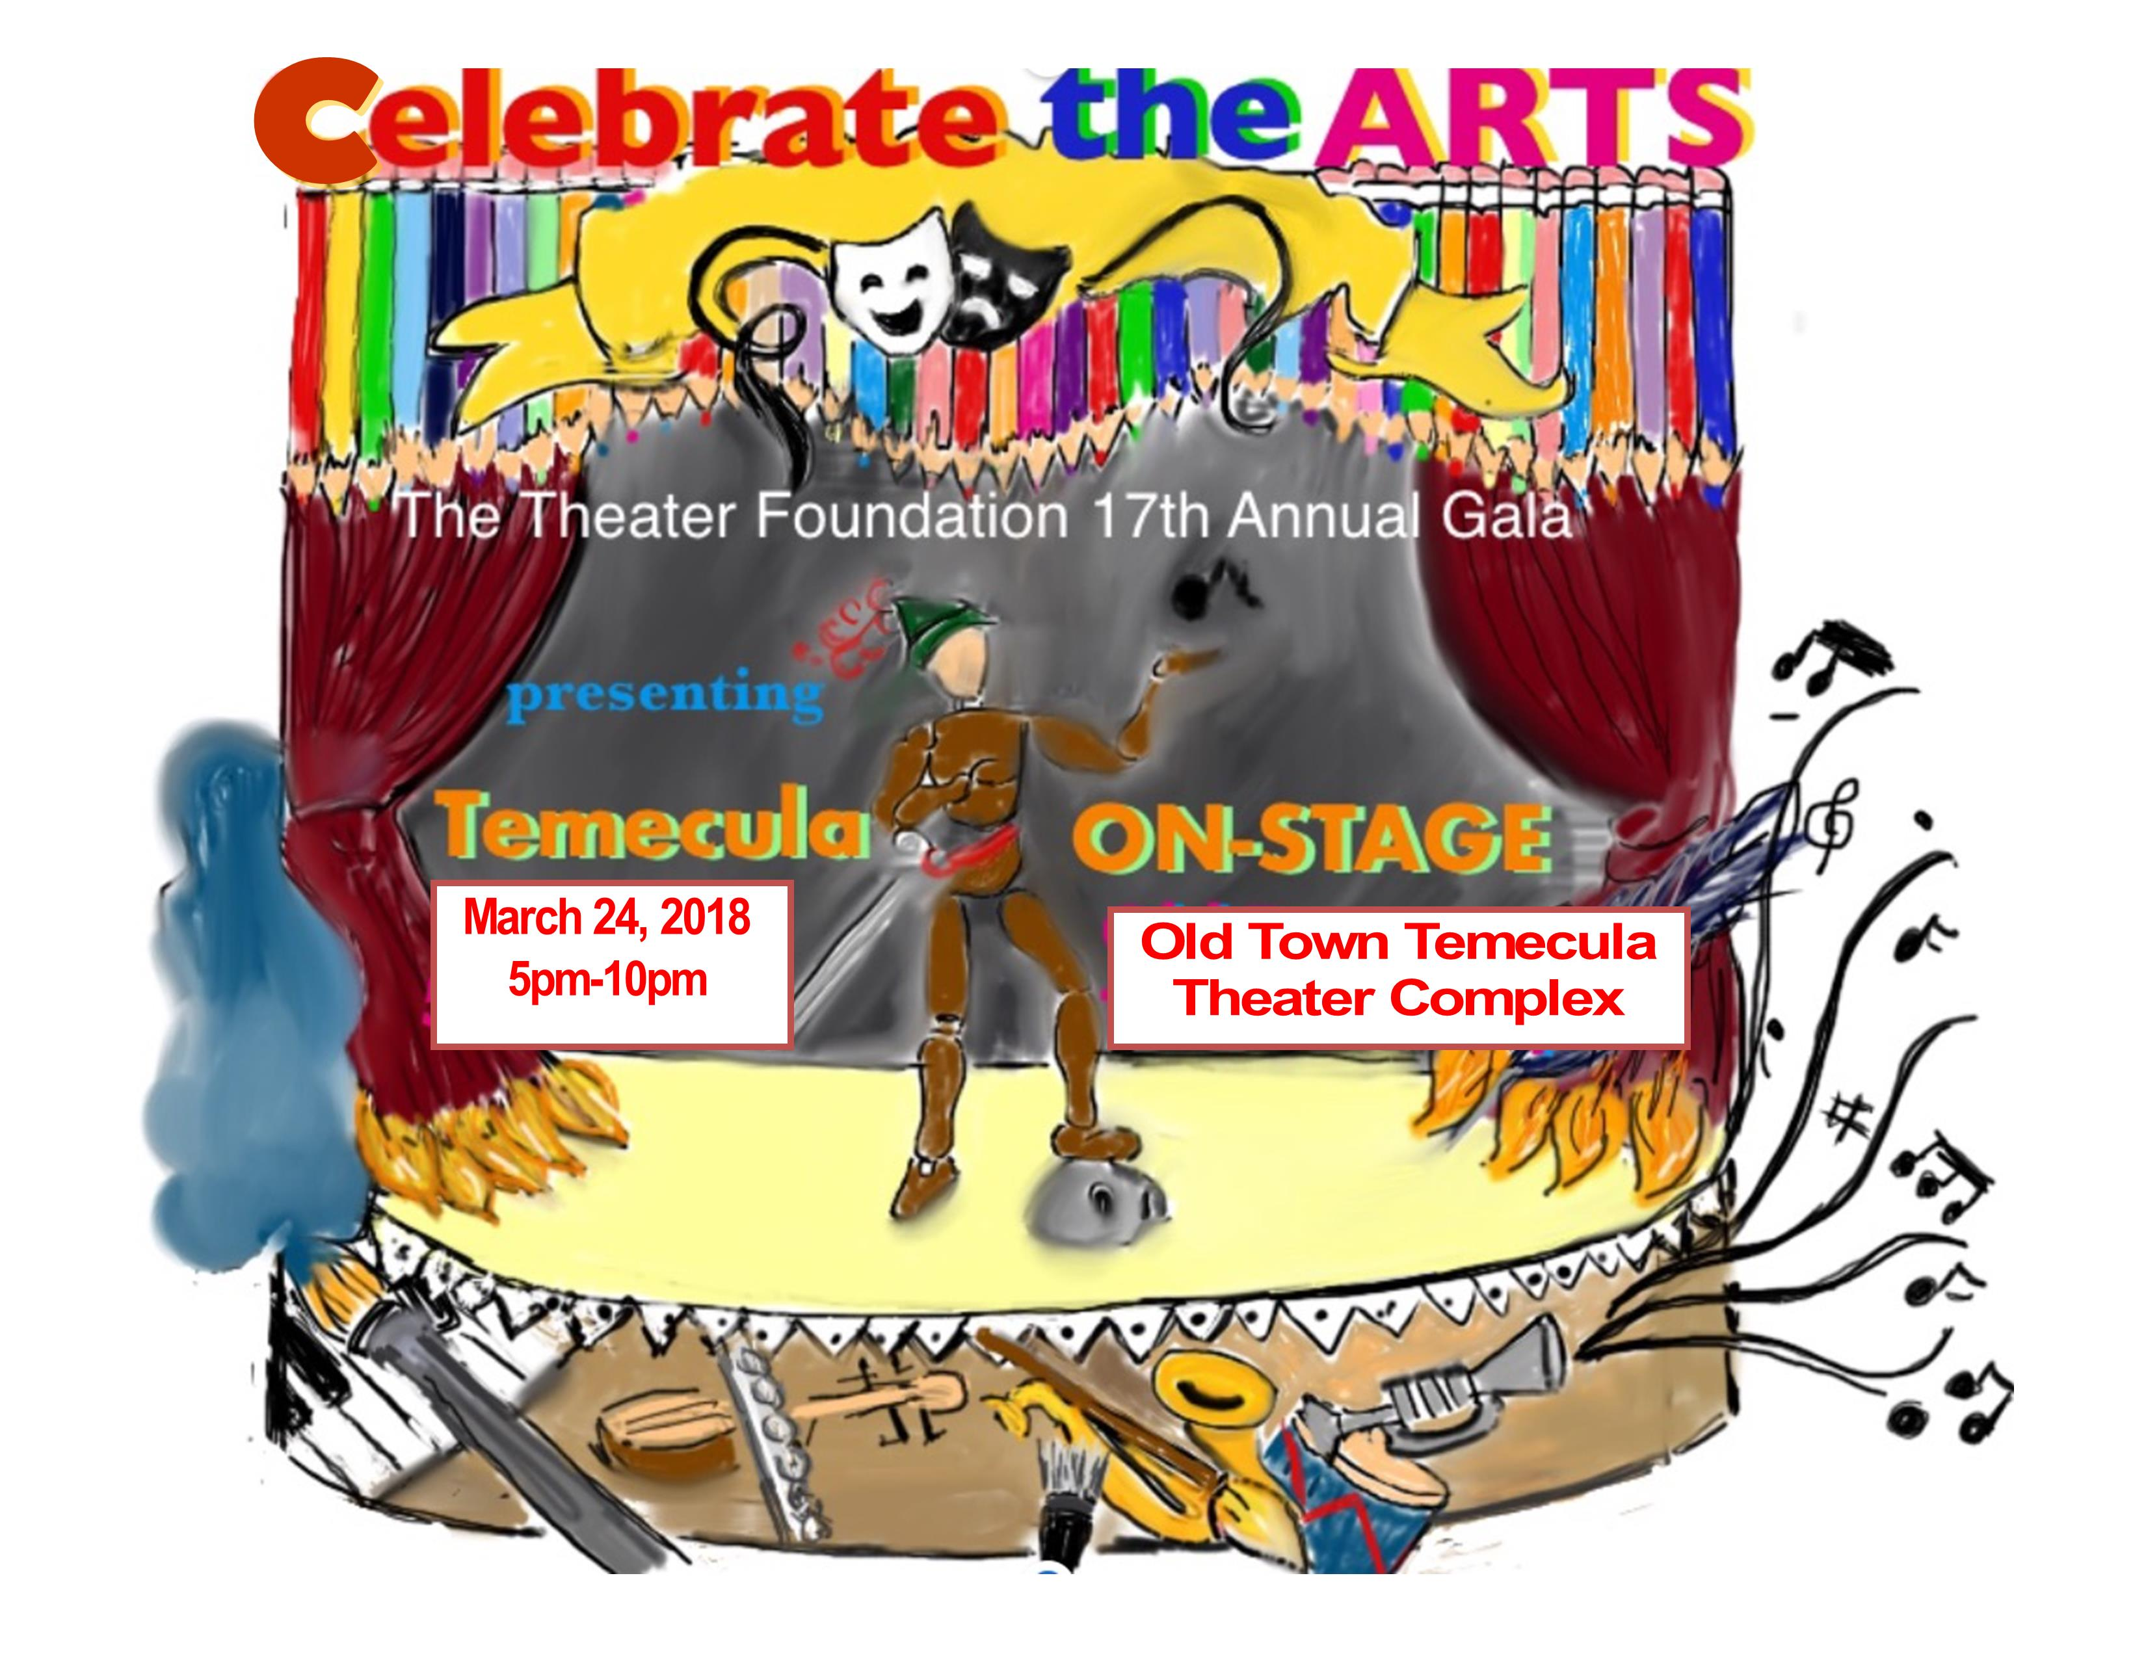

The Temecula Theater Foundation
Federal Tax #33-0871129
41391 Kalmia #200
Murrieta, CA 92562

