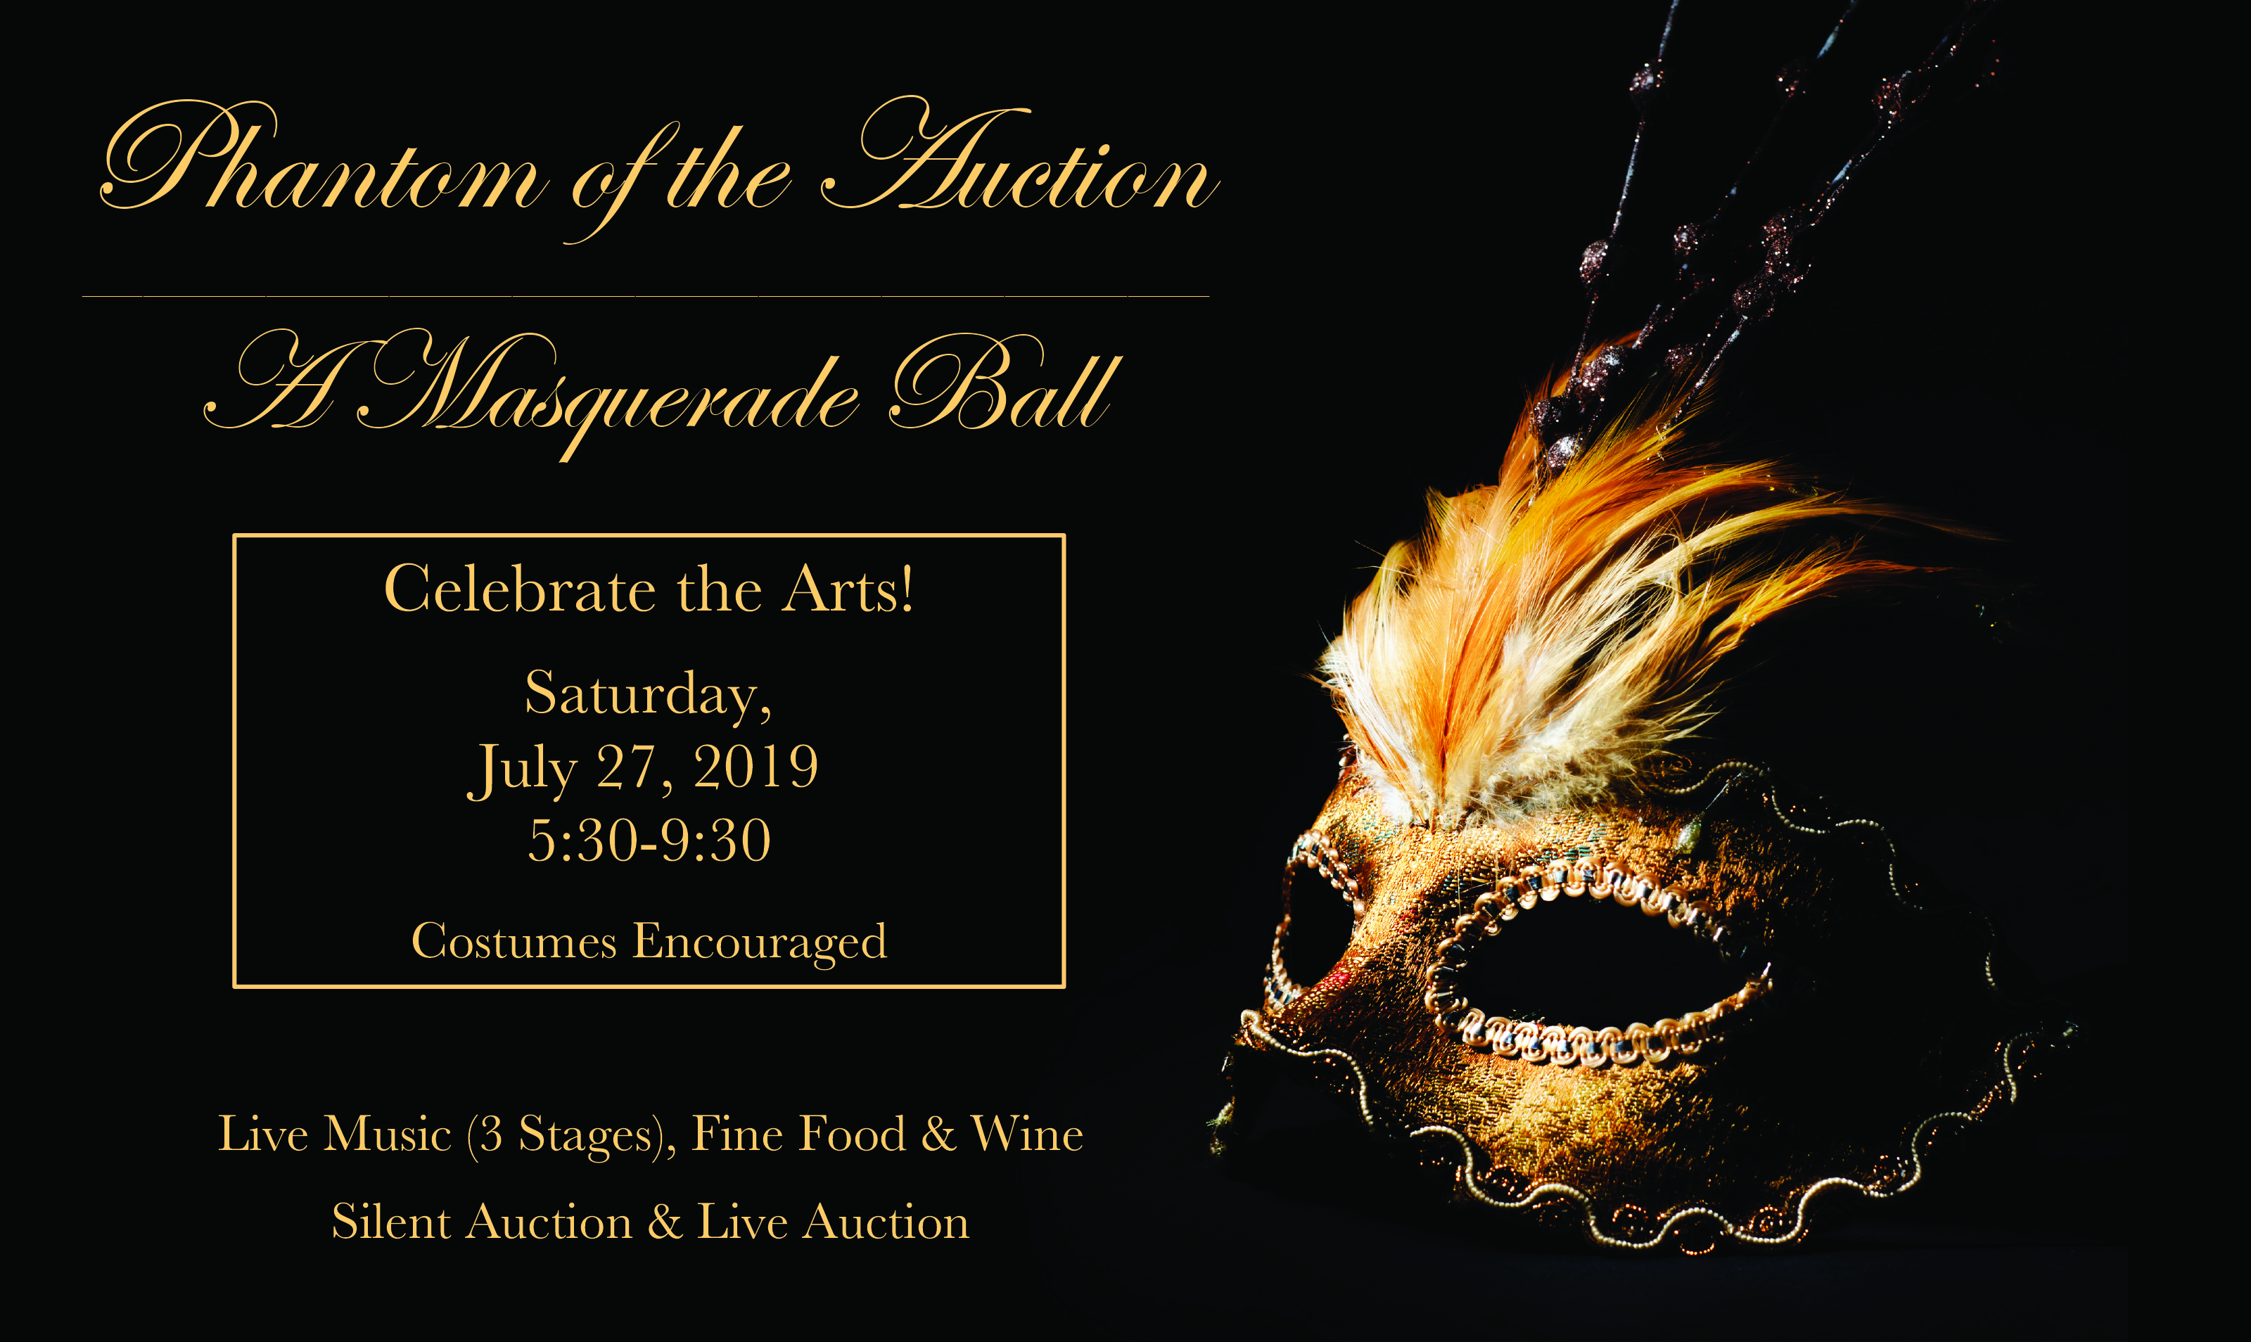

**18th Annual Gala & Auction**

**to Benefit The Theater Foundation**

**Sponsor Information**

Business Name: ____________________________________________________________________________

Address: ____________________________________________________________________________________

Contact Person: ____________________________________________________________________________

Phone: __________________________________ Email: __________________________________________

**Sponsorship Amount**

☐ $500 ☐ $1,000 ☐ $1,500 ☐ $2,000 ☐ $2,500 ☐ Other ___________

The benefits for being a sponsor will include tickets to the Gala and recognition on the program.

**Thank You for Supporting the Arts!**

The Temecula Theater Foundation

Federal Tax #33-0871129